**Assignment 3**

NAME : Ashwathi.S

Reg num: 310119104012

STEP 1: Create a Bucket in IBM object storage.

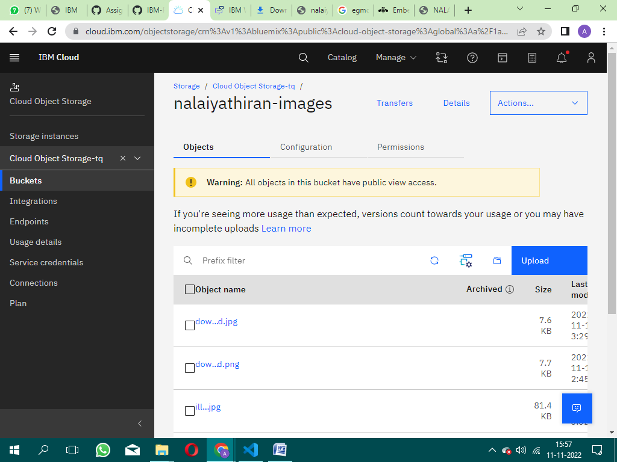

STEP 2: Upload an 5 images to ibm object storage and make it public. write html code to displaying all the 5 images.

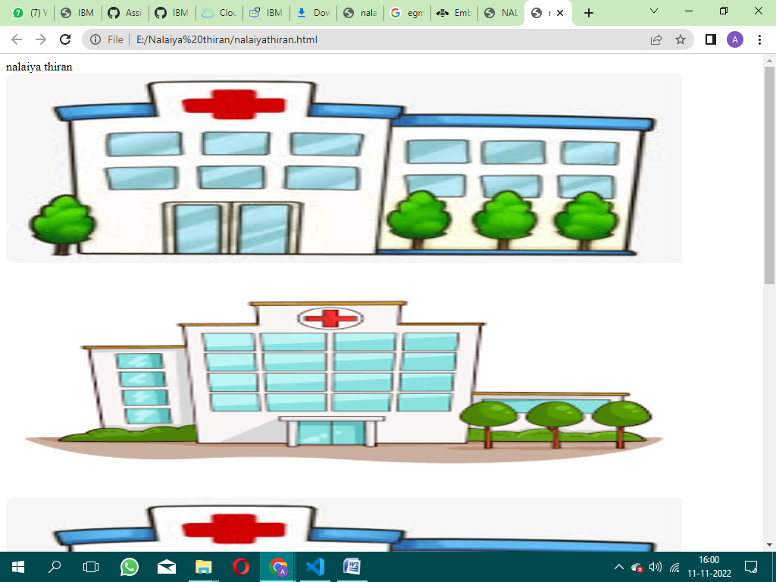

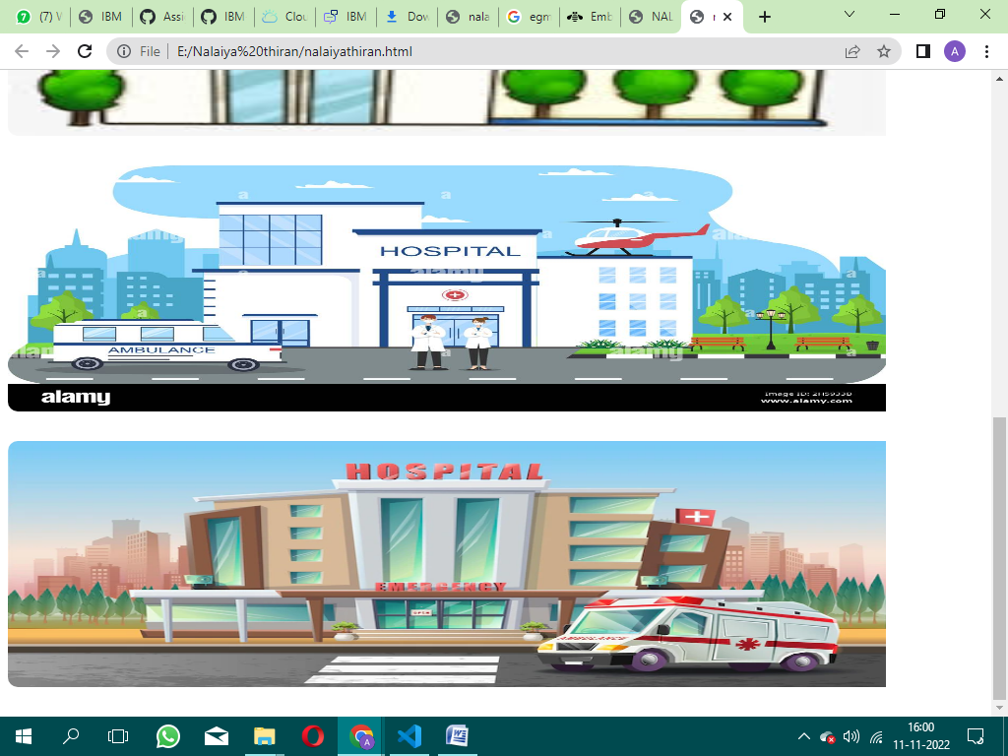

Step 3 : Design a chatbot using IBM Watson assistant for hospital.

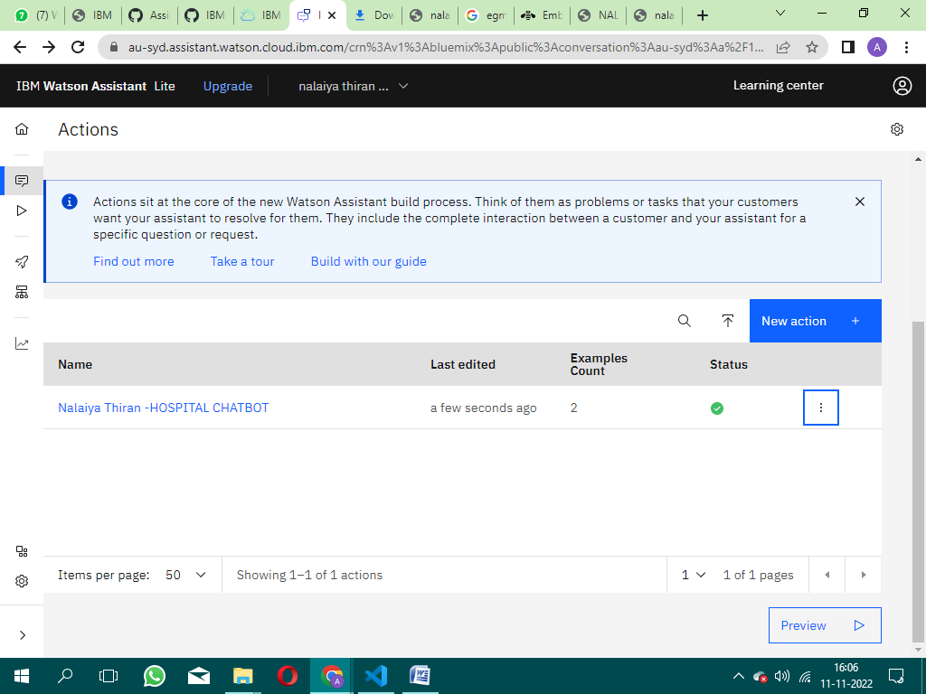

STEP 4: Create Watson assistant service with 10 steps and use 3 conditions in it. Load that script in HTML page.

